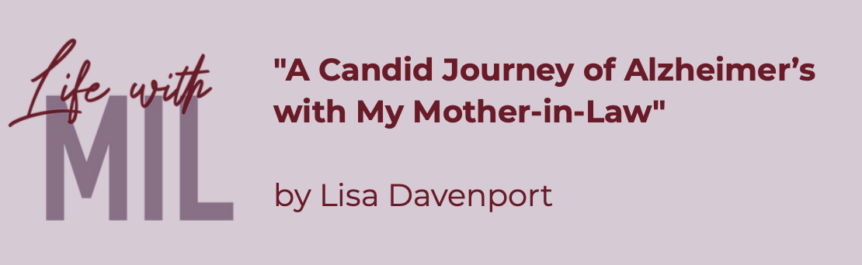

- Would you recommend this book to someone? Why or why not (or with what caveats)? What kind of reader would most enjoy this book?

- Did any part of this book strike a particular emotion in you? Which part and what emotion did the book make you feel?

- How much did you know about this book before picking it up? What surprised you the most about the book?

- How thought-provoking did you find the book? Did the book change your opinion about anything, or did you learn something new from it? If so, what?

- Did you highlight or bookmark any passages from the book? Did you have a favorite quote or quotes? If so, share which and why? Did something stick with you?

- From your point of view, what were the central themes of the book? How well do you think the author did at exploring them?

- How would you adapt this book into a movie? Who would you cast in the leading roles?
- Did you think the first sentence of the book was effective? Why do you think the author started with that sentence?

- What was your favorite quote from this book and why?

- Do you feel the book cover captures the essence of the book?

- If you could ask the author one question about the book, what would it be?

- Would you read another book by this author? Why or why not?

